Chimzim Ogbondah

SE 319

Homework 3

Design Analysis

For snake.html I used a simple design where I create three buttons and a canvas. The buttons “Start” “Turn Left” and “Turn Right” which each call a function gameMode() for “Start” and turnLeft(), turnRight() for “Turn Left” and “Turn Right”. The gameMode() function checks the value of the “Start” button. If it is equal to start it settings Boolean variable to true and then resets the value of the button to “stop”. IF running is true a timer is created that runs every second that calls the function makeNewBlock(). The function makeNewBlock takes global variables that keep track of the snakes position increment the position based on the snakes size and then makes a rectangle at the position of the snakes size . From there the rectangle is filled on the canvas creating the path the snake is traveling. The turn left and right functions work by taking a string value to see the orientation of the snake (which way it is facing) and then based on the function call changes the global move positions which update the Pos of the snake. If the value is equal to Stop it Stops the timer changes the value of the button back to “start” and then sets the Boolean variable back to false. The game also stops if the x and y values exceed the boundaries and this happens by checking if x or y < 0 or x > 1000 or y > 750

For Task2 I looked at the example.js to understand how to request an input from the command line. From there I then requested 4 inputs from the user. I created variables to house the results for each output based on the number entered. The first output was factorial so for this one I call number() on the input changing it to a number I then have fact = 1 (which I will print back to the user) I then loop from the fact down to 1 multiplying it by the looping value. The second number requested the sum of all the numbers so for that one I call Number() the input and then modulo it with 10. This gives me the least significant bit. I then add this number into the var sum. And divide the users input number by 10 while also calling the floor value so it rounds down as an decimal value would give me the wrong value. I repeat this while the users input number is greater than zero. For in reverse order I simply left the users input as a string and looped through the input starting at the end adding each index into a new var. when I call the var at the end I use Number() to turn it back into a number. For the last output I had the variable set to true because this one is checking for a palindrome. If the length is >= 1 it returns false. I then loop through half of the length of the input checking the respectively the first and last, second and second to last to see if they are the same. If they aren’t the same I again return false. I then return this value for the result.

Screenshots:

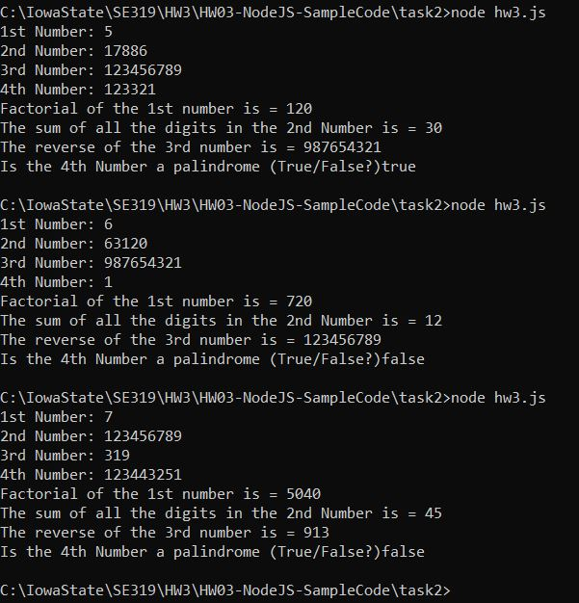

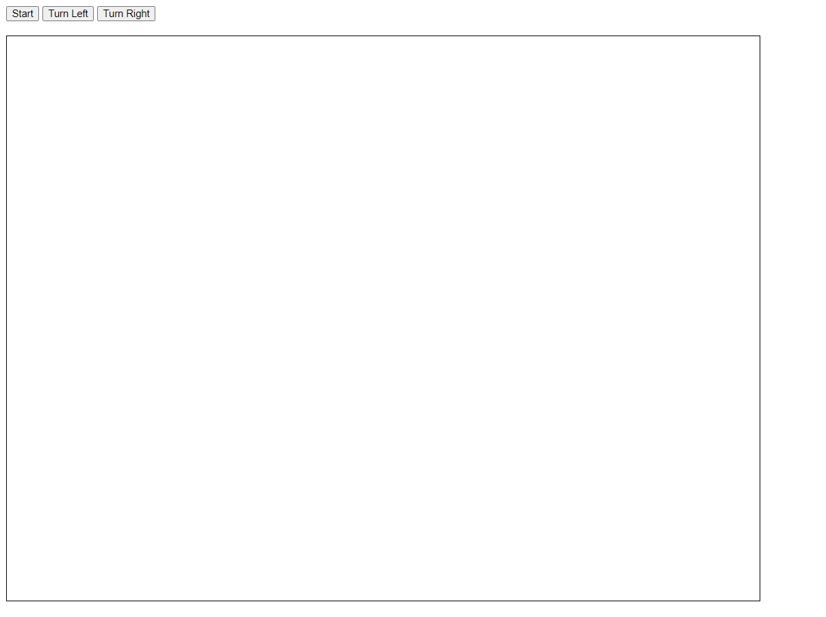

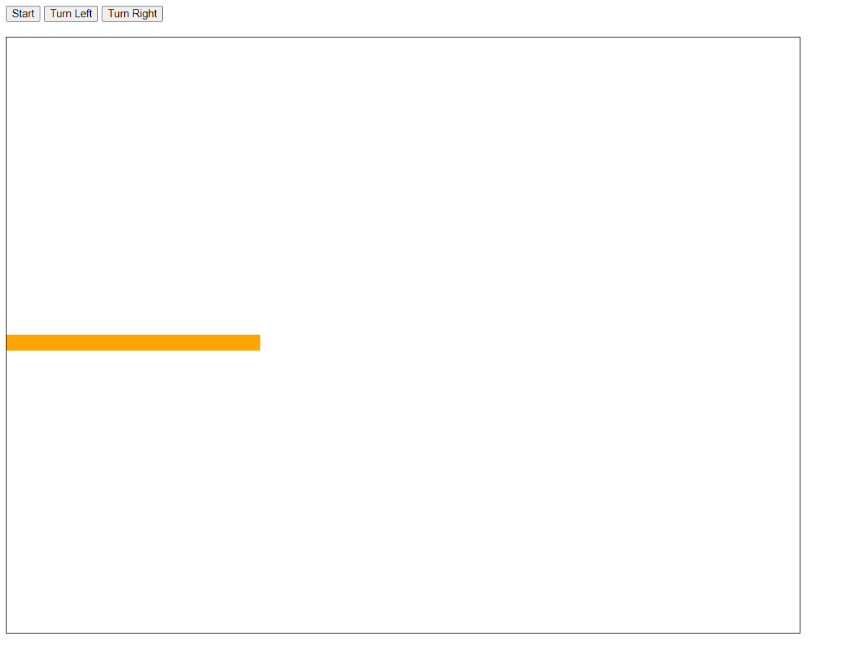

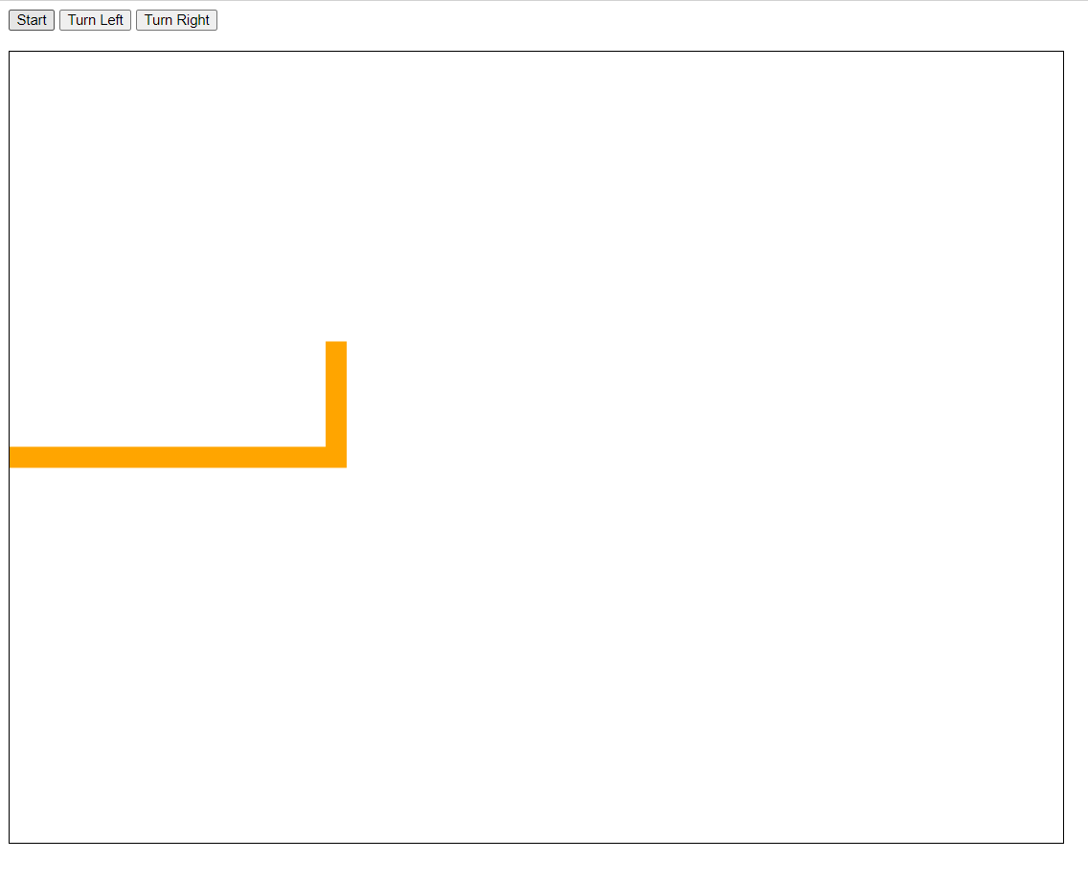

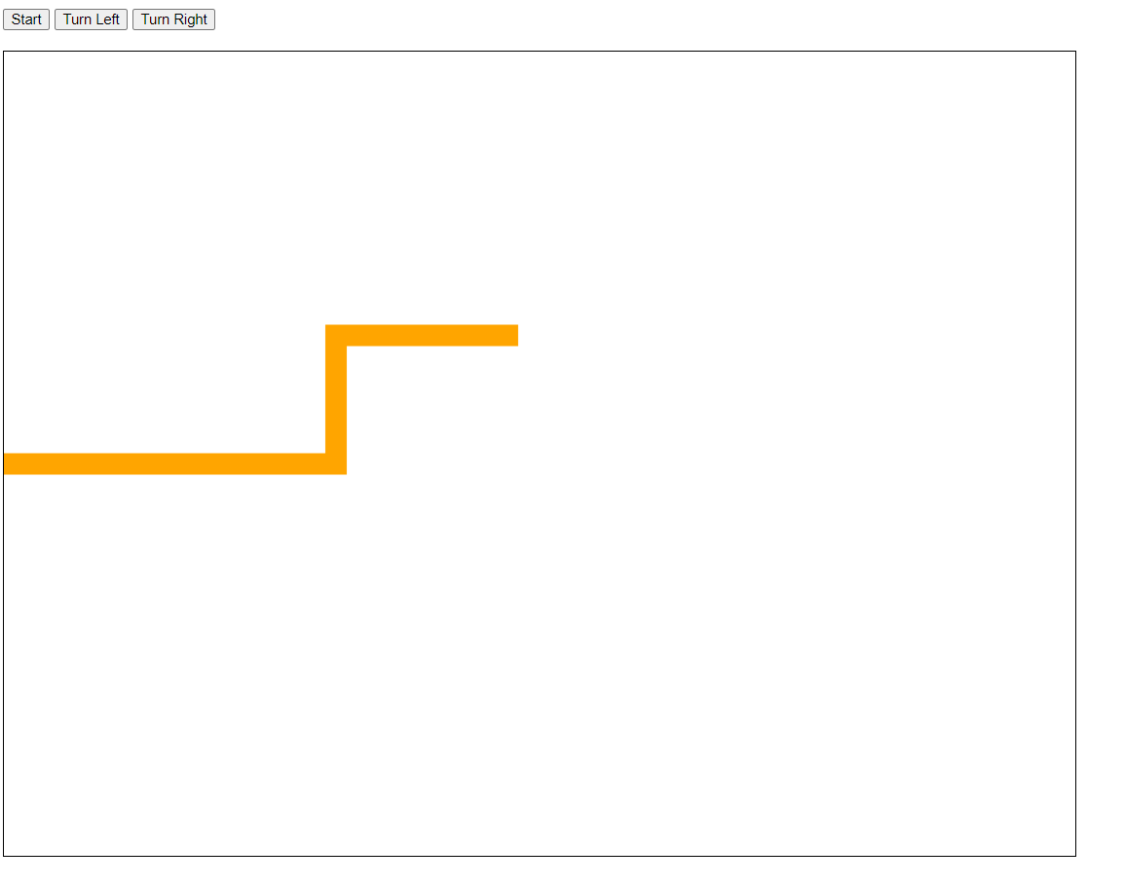

Note: button value changes back to start as the game ended

